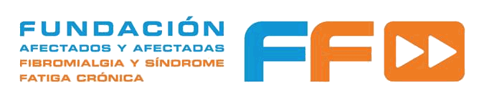 LOGO

12 MAY
INTERNATIONAL AWARENESS DAY FOR FIBROMYALGIA AND CHRONIC FATIGUE SYNDROME 2015
What hurts us most is the pain of misunderstanding. This idea defined the contents of the First Manifest in 2003 in commemoration of the World Day of Fibromyalgia and Chronic Fatigue Syndrome.

Today, in this twelfth Manifest, we continue to blame, as the main cause of our condition as “hole-and-corner” patients, the misunderstanding from which our diseases suffer. And we rebel against it.

For, though the pain and fatigue never cease, they have hardened us personally to face them, they have made us not forget that we are people who have families, dreams and legitimate aspirations, and a sense of dignity and our rights that force us to claim them.

For years we have invested our longings and dignity in patient associations that were created throughout Spain to fight for our rights. Entities that have gone through evolving, demanding and supplying deficiencies. Joining efforts, sharing experiences, fighting side by side with each other.

Entities that have been looking for new ways in this struggle on part of the civil society. Some, asserting directly and frontal rights of patients; the others, committed firmly to promote research to get to the root of the problem, which is just to seek healing of the disease. ALL of them, from the generosity of the social service for the common good.

The social service that requires effective and concrete actions and implications of the health professionals, the compromise of the politicians, the efficiency of the public administrations and the complicity of all the society.

To achieve this, we would like all the people who are listening to us today, feel and praise our hope and recognition of the achievements and join us in denouncing the inequalities and injustices that persist in order to envisage a future with full normalization of patients and their families in society and in the Social and Public Health System.

Sufferers of Fibromyalgia and Chronic Fatigue Syndrome believe that to improve our quality of life and that of our families, the priorities are:
- The recognition of the disease by professionals, institutions, social partners and society in general
- The research for better diagnosis, treatment and early detection
- The improvement of health care and the establishment of unified protocols that ensure the equality in quality and accessibility to resources and services of the Public Health System
- Access to work, either through the jobs adaptation or through new forms of employment
- Fair social benefits when the severity of the disease doesn’t allow to work.
On this International Day of Fibromyalgia and Chronic Fatigue Syndrome, we, the sick people and the entities that defend us, lift up our voices, proclaim our demands and accept the challenge of being jointly responsible for the management and improvement of our diseases.
As we said, people with Fibromyalgia and Chronic Fatigue Syndrome want a better quality of life for ourselves and our families. It is the responsibility of all to have it. The time for excuses has already passed, now it's time of RESPECT, SOLIDARITY, and law ENFORCEMENT for all the patients to be treated as full citizens, ALL without distinction.
May 12, 2015

